Australian Energy Employment Report

# How to guide

### Acknowledgement of Country

We acknowledge the Traditional Custodians of Australia and their continuing connection to land and sea, waters, environment and community. We pay our respects to the Traditional Custodians of the lands we live and work on, their culture, and their Elders past and present.

### Background

Australia lacks data to understand energy sector jobs, including those working in other related sectors, the people in those jobs and their skills, and forecast how these jobs are changing.

The Department of Climate Change, Energy, the Environment and Water is addressing this gap through the delivery of the Australian Energy Employment Report (AEER), a national survey of organisations in the Australian energy sector.

You have received this document to support you to complete the consultation survey.

### What are the benefits of completing the AEER Survey?

The results of the survey will be used to develop the AEER. Your responses will:

* Give federal, state and local governments insights to assist in the development of policies regarding jobs, skills development and training opportunities in the energy sector.
* Support new government initiatives such as ensuring a transition pathway for fossil fuel industry workers and provide a snapshot of workforce diversity to support equality initiatives in the energy sector, such as Equal by 30.
* Allow organisations in the energy sector to improve industry-led workforce planning, support business opportunities and direct industry investment.

The department will use learnings from this survey to develop a business case to build on the capability of the AEER and broaden its data collection in future years. The department is aiming for a full-scale survey to determine sector size and allow projections.

### What types of organisations should complete this survey?

The survey is targeting businesses/organisations in, or directly involved with, the Australian energy sector.

### We define businesses/organisations in the energy sector as being directly involved with all activities relating to:

### Electricity (including generation, transmission, distribution, storage, and market operation)

### Energy retailing (including electricity and gas)

### Energy supply services (including trades providing general electrical, plumbing/gas fitting, HVAC, refrigeration, rooftop solar and batteries etc. to buildings)

### Fuels (including extraction, processing, production, distribution, and market operation)

### Managing energy use (including products and services relating to energy efficiency, energy management and demand management/flexibility)

### Support services (including advocacy, consulting, education and training, financial, legal and other professional services, policy, ICT, Research and development)

### What about supporting organisations and staff?

The intent of the AEER is to capture all energy employment in Australia. While this includes organisations directly involved in energy (e.g. electricity generators), it also includes the supporting organisations required by the sector (e.g. legal, financial, administration and education).

### Who should complete the survey?

The survey asks questions about the business/organisation as a whole. Therefore, the survey should be completed by someone with sound knowledge of the organisation, policies and workforce, for example:

* Directors
* Owners
* Senior managers
* HR managers

### What do you need to complete the survey?

To complete the survey please ensure you have information on:

* Business/organisation’s information including:
  + Business name and trading name (if applicable)
  + Australian Business Number (ABN)
  + High level breakdown of business locations
  + Relation to the sector and key activities
* HR information including employee number breakdowns (where collected) across:
  + Full-time, part time and casual
  + Employee roles (e.g. by cost centre)
  + Employee indicative level (e.g. management, professional, trade)
  + Apprentices/Trainees
  + Diversity information (where collected):
    - Gender
    - Age brackets
    - Indigenous employees
    - Culturally and linguistically diverse (CaLD) employees
    - Employees with a disability
* General understanding of organisational HR policies, including:
  + recruitment
  + retention
  + learning and development
  + diversity and affirmative actions

For numerical questions, if workforce data is not formally collected within your organisation, please provide a careful estimate for each question for the organisation.

### What about businesses/organisations with multiple ABNs?

Where a business/organisation has multiple ABNs, the survey can either be answered on behalf of the whole organisation under the parent ABN, or on behalf of the area the respondent has the most knowledge and information on.

We ask that when answering on behalf of the whole organisation, respondents coordinate internally to ensure responses are not duplicated.

### How long does the survey take?

Depending on the organisation, we anticipate the survey will take respondents between 30 minutes and one hour. This is dependent on the respondent having access to information on the survey.

### Where is the survey?

Information about the AEER is located on [energy.gov.au](https://www.energy.gov.au/aeer)/aeer.

The survey itself is available at this [link](https://app.converlens.com/climate-au/aeer/survey). The survey uses a platform called Converlens. Converlens complies with the *Privacy Act 1988* and stores data securely in Australia.

### How do I navigate the survey?

The survey overview can be seen on the sidebar on the left. You can navigate between sections by clicking the section headings.

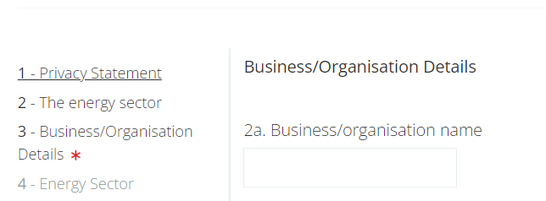

Next and back buttons at the bottom of the survey move through pages. You can return to previous answers if required. Please note some questions are connected.

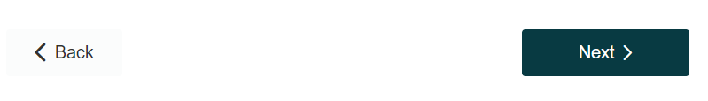

The progress bar gives an indication of survey progress: 

If you would like to start the survey over, you can hit the reset all answers button, below the navigation buttons. You will be prompted to confirm.



A red asterisk indicates a mandatory response:

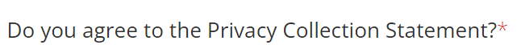

### Saving progress

If you need to exit the survey before completion or share with others in your organisation, you can save your progress by clicking on the button below the survey navigation:

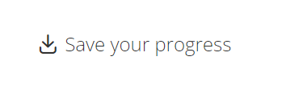

This will take you to a page where you can generate a unique link for your survey form.

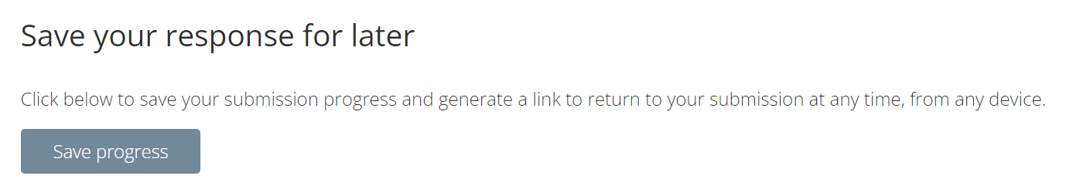

### Question types

#### Multiple choice

Where a question has a check box , please select all answers that apply.

For a radio button , please select the most relevant answer.

If your answer is not shown, please select “Other- Specify” and a text box will appear.

#### Numerical

Some questions ask for a number or proportion. These fields will not allow you to enter a non-numerical value. In the case of proportions, please enter as a whole number, without a percentage (%) sign.

#### Open Text

Please provide a written response. Where a character limit is enforced, you will be notified in the question text.

### Survey Dates

#### Survey Reference Date

Please provide your responses based on the business/organisation’s most current data at the reference date of 30 January 2023.

#### Survey close date

Please complete and submit your survey before the survey end date, 5:00pm (AEST) 30 April 2023

### Survey help

If you have problems with completing this form, please contact the AEER team via:

**Telephone** (02) 6243 7815 **Email** [AEER@industry.gov.au](mailto:AEER@industry.gov.au)

## Acknowledgements

# The Department of Climate Change, Energy, the Environment and Water would like to acknowledge the expertise, time and effort of the Stakeholder Reference Group. To see a list of SRG members, visit the [AEER webpage](mailto:https://www.energy.gov.au/government-priorities/energy-workforce/australian-energy-employment-report).